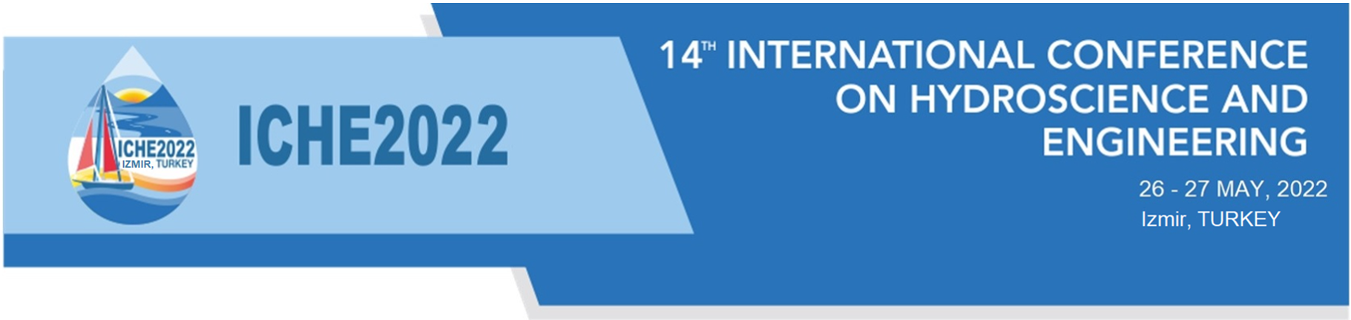
Copyright Transfer Agreement

The author has submitted a manuscript entitled ………………………………………………………………………………….to be published in the proceedings book of the 14th International Conference on Hydroscience & Engineering (ICHE 2022).
The authors warrant that this submission is an original work and has not been published before and being considered for publication elsewhere in its final form. The authors also affirm that this submission does not contain any material that is unlawful, and that this submission does not contain any material that invades the right of privacy or any proprietary right.
The undersigned author (who is corresponding author of the paper with the consent of the co-authors if any) transfers ownership of copyright, including the right to publish and distribute the work by any means, methods or process whether now known or to be developed in the future, to the ICHE2022 in the event that the work is published by the conference organizers.

Name Signature Date

_______________________ ______________________________ ___ / ___ / ________

